
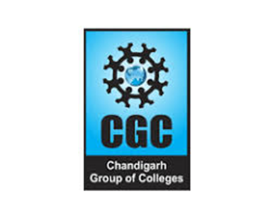

Medical Application on Blockchain
8th Sem Final Project (BTCS-703-18)

Presented by: Under the guidance of:

Anurag Dr. Sachin Bhardwaj

1801994 Asst. Professor

CSE-CEC Dept. of Computer Science

CGC Chandigarh Engineering College, Landran



Contents

Introduction | MEDICOS | Why this?
Problem Statement | Process Flow - Tech | Results
Project Objective | Process Flow - App | Future work
Tech Implemented | Demo

Introduction

Medical Applications should be more tied to the upcoming technologies.

Leverage the full potential of Blockchain in the medical field.

User-friendly

Solve user’s problems

Literature Survey

S. No. | Authors & Title of Research Paper | Published |  | Merits
1. | D. C. Nguyen, P. N. Pathirana, M. Ding, and | 2019 | ● | Ethereum mainnet usage
 | A. Seneviratne, “Blockchain for secure ehrs |  | ● Storing data on Blockchain
 | sharing of mobile cloud-based e-health |  | ● Unique Identification not present
 | systems”
2. | B. Shen, J. Guo, and Y. Yang, “Medchain: | 2019 | ● Manual Sharing by patient
 | Efficient healthcare data sharing via |  | ● | Scalability
 | blockchain”
3. | M. A. Uddin, A. Stranieri, I. Gondal, and V. | 2018 | ● Single miner, mining all blocks
 | Balasubramanian, “A patient agent to manage |  | ● | Choosing miner
 | blockchains for remote patient monitoring” |  | ● | Private blockchain compromised
4. | F. Jamil, S. Ahmad, N. Iqbal, and D.-H. Kim, | 2020 | ● | Scalability
 | “Towards a remote monitoring of patient vital |  | ● | Storage issues
 | signs based on iot-based blockchain integrity |  | ● Unique Identification not present
 | management platforms in smart hospitals”

Problems to solve

Some medical records are lost, mutated

1
& tampered.

Some hospitals show wrong results and
2
charge a lot of money to treat it.

3

4

Health records are not connected to a unique identification no. across the whole country and each hospital is maintaining a different set of records that needs to be unified.

The history of a patients’ data when trying to retrieve at a later stage takes a lot of time and not everything shows up.

Project Objective

Medical records cannot be mutated,
1
deleted, or tampered with anymore as the database is getting decentralized with the help of blockchain technology.

Each health record is connected to a
2
user’s unique identification number or Aadhar no. and we can get a unified & decentralized database all across the country.

3

4

Nobody at a later stage can show different results as once written on blockchain nothing can be changed.

Easily all the health records of a patient can be retrieved by searching by his aadhar no.
Technologies Implemented

- Blockchain: Blockchain is a system of recording information in a way that makes it difficult or impossible to change, hack, or cheat the system.

- Inter-Planetary File System: IPFS is a protocol and peer-to-peer network for storing and sharing data in a distributed file system. IPFS uses content-addressing to uniquely identify each file in a global namespace connecting all computing devices.

- Web-Dev: Web Development is the work involved in developing a website for the internet or an intranet. Web development can range from developing a simple single static page of plain text to complex web applications and social network services.

MEDICOS

A large-scale health data application based on blockchain technology, where health data are stored with different levels of access controls and privacy policies to give the best benefits. Major roles: healthcare admins, doctors and patients.
Process Flow - Tech wise
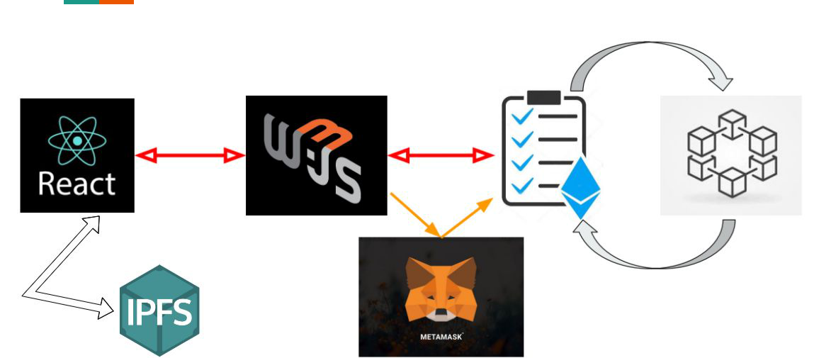
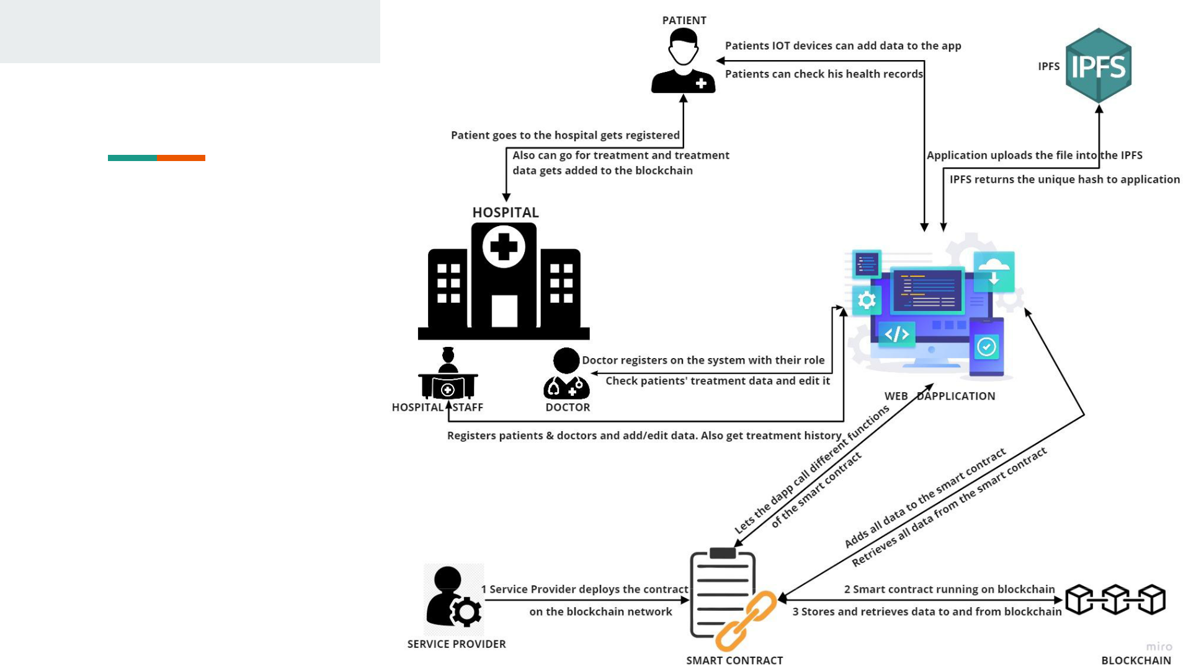
Process Flow Application


DEMO

Github URL: https://github.com/anuragsaini2472002/Medicos
Why this Application Dapplication

- All data addition and updation are securely done on blockchain.

- Data becomes Immutable and Decentralized.

- Details of Transactions stays forever and can be tracked at any point of time.

- No need to trust as smart contract automates it.

- Government can look into details
RESULTS

- Medical records cannot be mutated, deleted, or tampered with anymore as the database is getting decentralized with the help of blockchain technology.

- Each health record is connected to a user’s unique identification number or Aadhar no. and we can get a unified & decentralized database all across the country.

- Nobody at a later stage can show different results as once written on blockchain nothing can be changed.

- Easily all the health records of a patient can be retrieved by searching by his aadhar no.

- Reliable

- Robust

- Simple to use

- Scalable

- Decentralized
FUTURE SCOPE

- UI/UX improvement

- Integration with other applications

- Integration with AI

- Integration with IOT

- Connecting more hardware devices

- Automation

Thank you.

